ORIGAMI
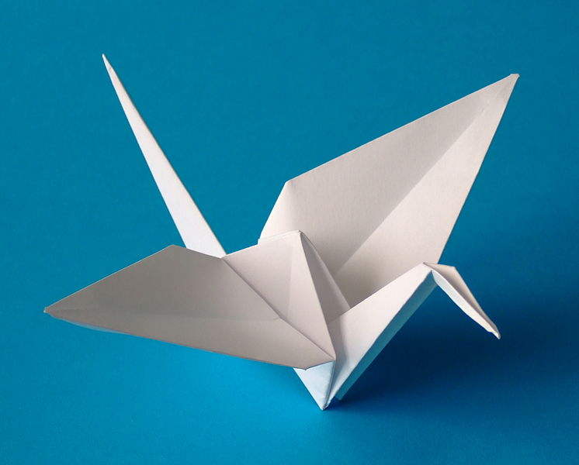
TABLE OF CONTENTS

____________________________________Prologue

_______________________________________Poem

_________________________________Advertisement

_______________________________________Journal

______________________________________Obituary

_________________________________________Note

____________________________________Notes Page

____________________________________References

Dear Reader,
I chose to write about origami because of a gift I received from a friend: a jar filled with one thousand paper cranes. Their strange beauty fascinated me and ever since, I have been looking for a chance to explore the art form.
This project is meant to be read as a research based report. Each original piece of writing was created in a fictitious manner, though the information itself is based in fact. Please refer to the notes and reference pages to determine which information is verifiable fact and which is merely entertainment.
The pieces of individual origami were all folded by me and the repetends throughout the report are meant to teach you how to fold your very own origami by the end of your reading.
Do enjoy learning something new.

Gina Mendola

1. Start with a perfect square sheet of paper.
2. Fold paper in half. Unfold. Fold paper in half the other way.
3. Repeat step two along diagonal lines.
4. Fold upper right hand corner down so that the right side of the square lines up with the center diagonal.

one thousand paper cranes

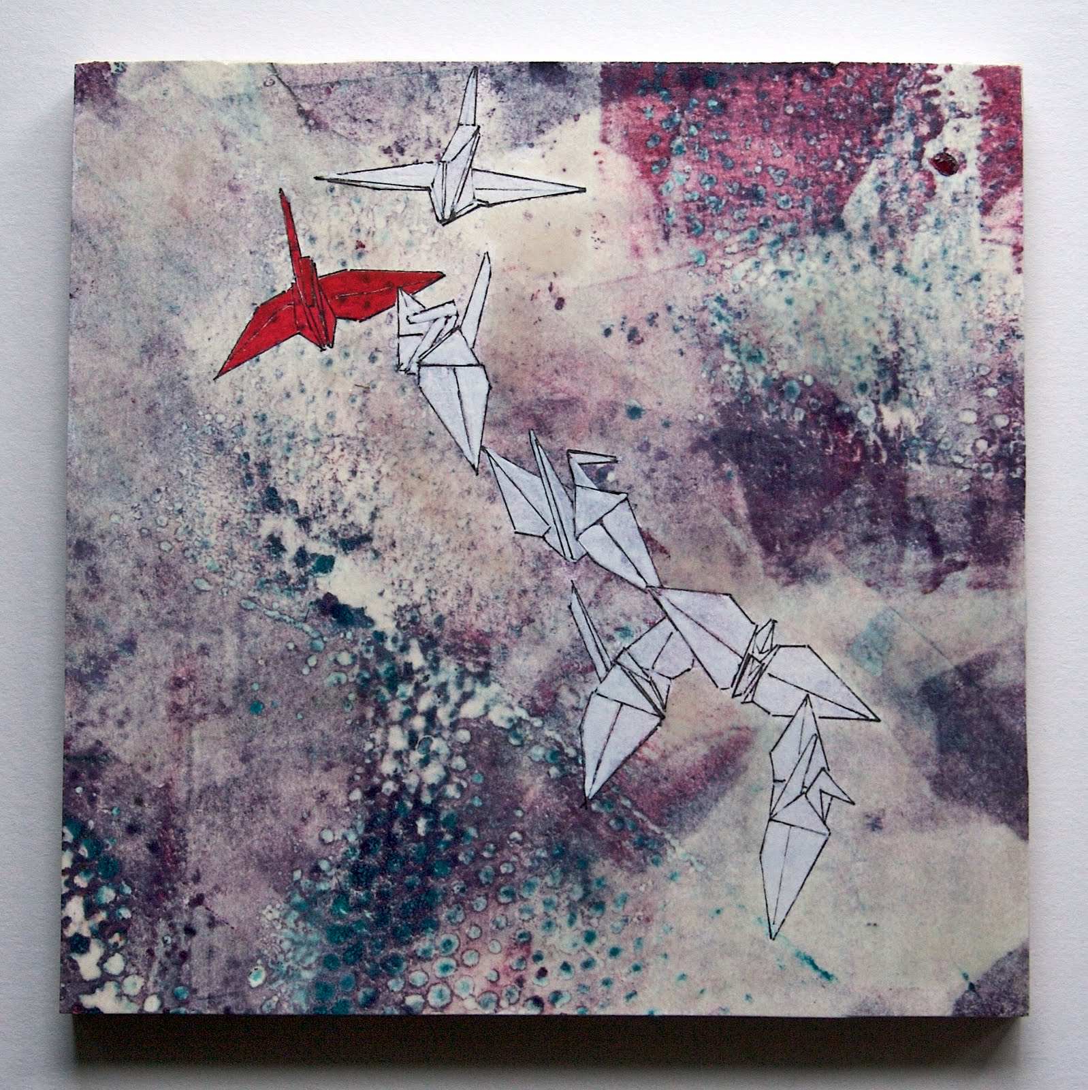
the last time I saw my best friend was
three years ago -
saying goodbye,
barefoot on her stone patio.
she handed me a
single paper crane
and told me,
one day,
I’d understand.
the next morning,
midway through her flight,
I got a package:
a glass jug filled with
one thousand paper cranes.
I thought maybe her message was
hidden inside their folds,
but I couldn’t reach the cranes
without smashing the beautiful jug.
I analyzed their colors,
their patterns,
the angles the wings of one
touched the feet of another,
and still nothing.
no message,
no idea of what I should understand.

but today I learned
with every thousand paper cranes
comes a wish.
and I wish those cranes were strong enough
to carry me across the ocean.
I wish their worn, papery skin
was the leather of her hands
and their whispery rustle of movement,
the sound of her voice.
I wish they would bring her back.

5. Fold bottom left hand corner up so that the bottom side of the square lines up with the center diagonal.
6. Rotate the square to complete steps four and five on each corner.
7. Unfold completely and refold along the horizontal crease.
8. Fold upper left corner along diagonal crease so the left side of your rectangle lines up with the bottom

LIMITED TIME OFFER
Get Your Kami at 40% Off
This Week Only
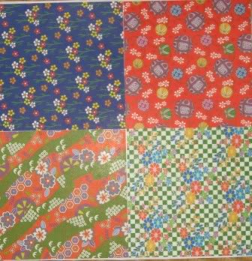
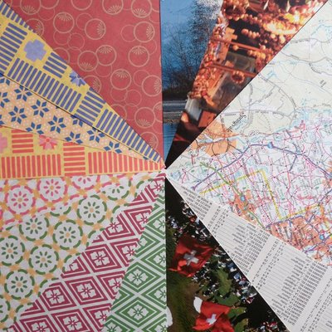
Check out our store at:
10-5, Akasaka 1-chome,
Minato-ku, Tokyo 107 (, Japan)
Or contact us at 108 8282

We carry specific kami for:
- Tsuki (accompanies a valuable gift and serves as a certificate of authenticity)
- Noshi (accompanies a gift as a measure of good fortune)
- Tsutsumi (formal gift wrappers)
- Mecho and Ocho (a specific kind of butterfly paper and design used to decorate wine bottles at weddings)
As well as everyday papers for friends and loved ones
DON’T MISS OUT ON THE NEW TREND IN PAPER FOLDING

9. Flip paper around and repeat step eight.
10. Open bottom compartment created and collapse into a square.
11. Press folded corner into the center of the square.
12. Repeat on all folded corners.
Travel Journal: Overview
It’s been a long trip, readers – beginning all the way back in 105 A.D. I started my journey in China, in the hands of a man named Cai Lun, but it wasn’t long before our neighbors became curious. They wanted to know who I was. A Buddhist monk by the name of Doyko brought me over to Japan around the 6th century and they just loved me there! They tried to get me to forget all about Cai Lan and be a part of their culture forever. But alas I continued to travel, this time with the Moors. The Moors brought me over to Europe through the silk route, which I’m pretty sure was used for trading intricate cloth that looked like my very own kami. From there, I visited many countries, but my favorites by far were Spain and Germany. I met a man named Miguel Unamuno in Spain between the 8th and 12th centuries (the years sort of run together when you’re on the road for so long) and he let me help him design the very first windmill the world had ever seen! I also met a teacher in Germany named Friedrich Froebel and he introduced me to his kindergarteners. He asked me to come in to play with them for quite a few years; I never knew I was so interesting. Teachers in the states heard about Froebel’s new friend and were very eager to meet me themselves but I decided to make a detour back to my friends in Japan. I ended up in the states somewhere between the late 1800’s and early 1900’s, working with Japanese stage magicians. After meeting so many westerners on the stage, my popularity began to grow. People wrote books about me and even built a place in New York City called the Origami Center in my honor. It’s crazy to think how many people still remember who I am since I started my journey so long ago. I don’t do much traveling anymore but a piece of me will always remain in each and every place I’ve been.
Yours in Memoriam,
Origami

13. Fold bottom tips of your kite upward.
14. Bring front horizontal corners to meet each other and repeat with back horizontal corners.
15. Turn paper so the “ears” are facing downward. Fold Top tips down.
16. Bring front corners and back corners to meet each other.
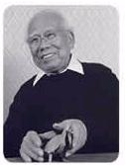
Akira Yoshzawa
Known by many as the father of creative paper folding, Akira Yoshzawa is a name that will live on in Japanese culture forever. Not only did he single-handedly expand the dimensions of origami forms, Yoshizawa made paper folding accessible to the common people. Because of his contributions, origami remains a Japanese art form and has even migrated west to the United States.
Origami originated as a formal tradition in China around the year 105 and was carried over to Japan about 5 centuries later. Initially, origami was used mostly for weddings and other formal occasions as symbols of luck but occasionally, important documents were enclosed in origami so as to assure they were not tampered with.
Because such formal occasions were rare and kami (or the paper used to create origami) was expensive, only the most elite were familiar with origami. In the 1930’s, Akira Yoshizawa began to develop a system of symbols to illustrate the folding of origami, and in January of 1952, his symbols were published in a magazine called “Asahi Graf”.
On top of making origami instruction available to lower classes, Yoshizawa’s symbols introduced a new type of creative origami focused on form rather than function. His new designs were featured in an exhibition at the Stadtlich Museum in Amsterdam in November of 1955 and grew rapidly in popularity from that point on. The bird base was one new creation credited to Yoshizawa and is still a central foundation to many forms today.

The Hochi Shimbun Obituaries
He also created patterns using two squares of papers while still resolving to create all shapes without the use of cutting.
Akira Yoshizawa passed away in 2005 at the age of 94. He lived a full life and the legacy of his work continues to live on through the generations. Yoshizawa took tradition and turned it into art, a true celebration of Japanese culture. Today that art form has migrated across the ocean to leave a lasting impression of Japanese culture on the western world, with great thanks to Akira Yoshizawa.

Your paper should look like this after step 19.

17. Bring top flap back down.
18. Fold front left corner so the outside tip touches the middle.
19. Repeat on all corners.
20. Fold bottom flaps upward
This is where it gets 3-dimensional. Use this sheet of origami paper to try it yourself.
21. Bring front and back corners to meet each other.
22. Gently pull down front and back flaps to form wings.
23. Bend or tug wings into desired shape.
24. Fold head down.
Notes
Title Page: I chose to use pictures of paper cranes on the title page because they serve as my inspiration for the topic of origami and appear as a general theme throughout the report. The pictures can be located at http://tmacwright.files.wordpress. com/2008/05/grulla-en-origami.jpg and http://www.foreverflying.com/origami-crane1lg.jpg. I used the small red squares to create the title in order to tie in the numbering system introduced in the table of contents.
Table of Contents: The repetends do not appear in the table of contents although they do contain page numbers throughout the report. The Japanese number system can be found at http://www.jessdoor.com/ anime/kanjinumerals.gif and is used throughout the report.
Poem: The one thousand paper cranes poem integrates the myth that folding one thousand cranes grants a wish (which I learned from source 1) and integrates it into the personal true story that inspired me to research origami. The picture can be located at http://1.bp.blogspot.com/ _e5mTyEJG8Yw/SxKc91SJTnI/AAAAAAAAAvE/3NTOx PPuV_w/s1600/One+Red+Paper+Crane.jpg.
Advertisement: The advertisement is a fictitious offer from a fictitious store. It was used to communicate the various formal uses for origami. The information on what kami (or the Japanese term for paper) is used for was found in sources 2 and 5 and the address format was found at http://www.japanorama.com/j_addr.html. The pictures can be located at http://media. photobucket.com/image/origami%20papers/ thecreativescrapbooker /Easter070.jpg and http://4.bp.blogspot.com/_MRY52 3E5qEk/SWwcwGQ9 ZII/AAAAAAAAAJs/I-oH04LEMS0/s400 /origamiout.jpg
Journal: The journal was written from the perspective of a piece of origami in order to tell the reader how the art of paper folding spread across the world. Sources 2, 3, and 5 were used to determine the dates, people, and locations involved in the spread of the practice of origami.
Obituary: I chose to write about Akira Yoshizawa because of the prominent role he played in the spread of origami’s popularity. The obituary was written using information about Akira Yoshizawa’s life and death found in sources 2, 3, and 5. The picture can be located at http://www.origami-resource-center.com/images/factoidsAkira.jpg.
Note: The note was written from the perspective of fictitious people in a fictitious situation. I chose this genre specifically to show the range of audiences origami affected and continues to affect. The information about color significance was found using source 6.
Repetends: Paper crane folding instructions were found at http://www.wikihow.com/Fold-a-Paper-Crane. Don’t become frustrated if the steps create nothing but a mess of folded paper. (I learned three dimensional instructions are hard to translate into a two dimensional display.)

References
1. History of origami. (1999, March). Retrieved from http://library.thinkquest.org/5402/history.html
2. Origami resource center. (2010). History of origami. Retrieved from http://www.origami-resource- center.com/history-of-origami.html
3. Lister, D. (2004, January 25). Origami history. Retrieved from http://www.paperfolding.com/history /partone/
4. Anderson, E. (2004, February 13). Origami history. Retrieved from http://www.paperfolding.com /history /partone/
5. PBS. (2009, November 30). Between the Folds. Retrieved from http://www.pbs.org/independentlens/ between-the-folds/history.html
6. Shea, L. (2010). Meaning of color in origami. Retrieved from http://www.lisashea.com/japan/origami/ sales/history/colors

